rate 



**FUNDAMENTAL SPREADSHEET APPLICATIONS**

(230)

**REGIONAL 2022**

**Production:**

**Job 1: Worksheets with answers and formulas __________ (170 points)**

**Job 2: Formatting Worksheet __________ (90 points)**

**Job 3: 3-D Pie Chart __________ (50 points)**

**TOTAL POINTS __________ (310 points)**

**Test Time: 90 minutes**

**GENERAL GUIDELINES:**

*Failure to adhere to any of the following rules will result in disqualification:*

1. Member must hand in this test booklet and all printouts if any.
2. No equipment, supplies, or materials other than those specified for this event are allowed in the testing area. No previous BPA tests and/or sample tests (handwritten, photocopied, or keyed) are allowed in the testing area.
3. Electronic devices will be monitored according to ACT standards.
4. Put your Member ID and printout number in the right section of the footer on each printout unless instructed otherwise. Your name or initials should *not* appear on any work you submit.
5. If you finish before the end of the testing time, notify the proctor. Time may be a factor in determining the winner in the event of a tie.
6. When turning in your contest, the jobs should be arranged in printout order.

**SCENARIO:**

**You work for Andrew’s Furniture Shop and are an assistant in the payroll office. Your boss is attending a department meeting on Thursday, and you need to have a spreadsheet report of the first 3 months of sales by each salesperson. It must also include the commission that the company has paid out for those three months to each of the salespersons.**

| **Job 1 (Worksheets with answers and formulas)** | **Points Possible** | **Points Earned** |
| --- | --- | --- |
| Member ID and Job # in right section of footer | 10 |  |
| 10 pt. Times New Roman font used for data | 10 |  |
| Landscape orientation with narrow margins | 10 |  |
| Worksheet printed landscape on one page centered vertically and horizontally | 10 |  |
| Type in cell A1 Andrew’s Furniture Shop | 5 |  |
| Type in cell A2 Sales Commission Summary | 5 |  |
| Type in cell C4 place .25 | 5 |  |
| Information shown in picture typed correctly | 20 |  |
| Insert 5 new rows at A16 | 5 |  |
| Enter the 5 new sales personnel information starting in cell A16 | 10 |  |
| In cell D7, insert a formula that calculates the sales commission in C4 and fill down to D20 | 10 |  |
| Copy and fill this formula to cells F7:F20 and H7:H20. | 10 |  |
| Place a formula in Cell I8 that calculates the total amount of commission each sales person eared for the three months and fill this formula down to I21 | 10 |  |
| Insert a formula in cell D22 that calculates the average sales commission for the month and copy to cells F22 and H22 | 10 |  |
| Insert a formula in cell D22 that calculates the average sales commission for the month and copy to cells F22 and H22 | 10 |  |
| Insert a formula in cell D24 that calculates the lowest sales commission for the month and copy to cells F24 and H24 | 10 |  |
| Insert a formula in cell D25 that calculates the highest sales commission for the month and copy to cells F25 and H25 | 10 |  |
| Print a copy of the worksheet with gridlines, adjust column widths to **make all data visible** | 5 |  |
| Print a copy of the worksheet with gridlines, adjust column widths to make all data visible with the **formulas showing** | 5 |  |
| **Subtotal** | **170** |  |

| **Job 2 (Formatting worksheet)** | **Points Possible** | **Points Earned** |
| --- | --- | --- |
| Member ID and Job # in right section of footer | 10 |  |
| Merge and center A1 through I1 | 5 |  |
| Merge and center the subtitle A2 through I2 | 5 |  |
| Format both the title and subtitle to a title cell style | 10 |  |
| Insert the image of the table set on the left of the title and subtitle. Format this image to a height of .77” and width of 1.19”. | 5 |  |
| Format the image with picture style “drop shadow rectangle” | 5 |  |
| Format cell C4 to a percentage | 5 |  |
| Add a border to the bottom of fro A6 to I6 | 5 |  |
| Add a double border style on the right side of cells D6:D20, F6:F20, and H6:H20 | 15 |  |
| Format C7:I20, D22:D25, F22:F25, and H22:H25 as currency with 2 decimal places | 10 |  |
| Sort the data on Sales Persons last name column in alphabetical order | 10 |  |
| Print out the formatted spreadsheet | 5 |  |
| **Subtotal** | **90** |  |

| **Job 3 (3D Pie Chart)** | **Points Possible** | **Points Earned** |
| --- | --- | --- |
| Member ID and Job # in right section of footer | 10 |  |
| Select the chart style 8 | 5 |  |
| Title the chart Total Commission Paid in the 1st Quarter to Salesperson | 5 |  |
| Title is Arial Black font size 12 | 10 |  |
| No legend shown | 5 |  |
| Salesperson shows sale as percentage | 5 |  |
| Pull out the pie section of the sales person with the largest percentage | 5 |  |
| Print out the formatted chart in black and white | 5 |  |
| **Subtotal** | **50** |  |
| **TOTAL POINTS** | **310** |  |

**Job 1 – Unformatted**

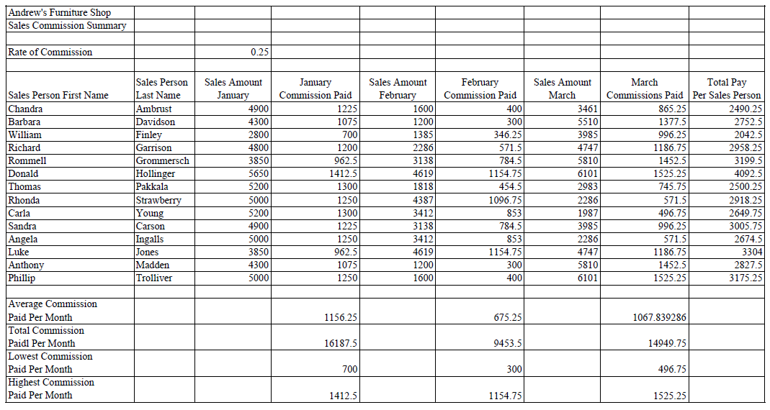

**Job 1 – Formulas**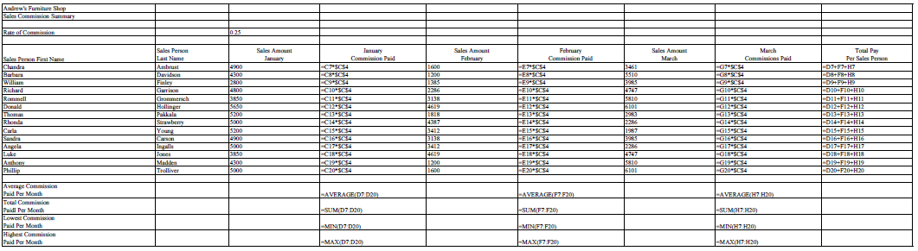

**Job 2 – Formatted**

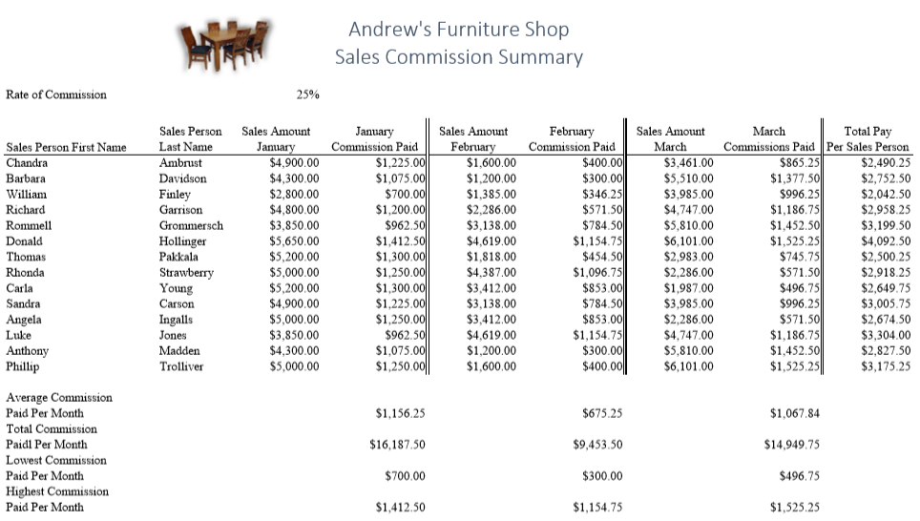

**Job 3 – 3-D Pie Chart**

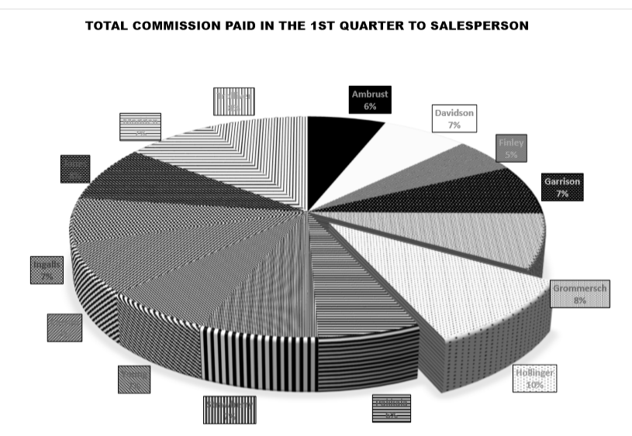

**NOTE: Make sure the MEMBER ID and JOB # is present on all.**