



**DATABASE APPLICATIONS**

(240)

**REGIONAL 2022**

**Production:**

**Job 1: Winter Sports Table __________ (100 points)**

**Job 2: Athletes Table __________ (100 points)**

**Job 3: Relationship Report __________ (50 points)**

**Job 4: Payment Query __________ (100 points)**

**Job 5: Letters Earned Query __________ (50 points**

**Job 6: Letters Earned by Type Report __________ (100 points**

**TOTAL POINTS __________ (500 points)**

**Test Time: 90 minutes**

## DATABASE APPLICATIONS

**SCORING SHEET**

|  | **Points Possible** | **Earned** |
| --- | --- | --- |
| **Job 1 – Winter Sports Table** |  |  |
| Correct field names (5 points per name) | **20** |  |
| Correct data entry (5 points per record) | **40** |  |
| Sports ID all Caps | **10** |  |
| Receive a Letter yes/no datatype | **10** |  |
| Wrote correct way of making Sports ID all CAPs | **10** |  |
| Printed using best fit | **10** |  |
| **Total for Job 1** | **100** |  |
| **Job 2 - Athletes Table** |  |  |
| Correct field names (5 points per name) | **30** |  |
| Correct data entry (3 points per record) | **33** |  |
| Input Mask for Phone Number | **12** |  |
| Sorted by Last Name | **10** |  |
| Printed using best fit | **15** |  |
| **Total for Job 2** | **100** |  |
| **Job 3 - Relationship** |  |  |
| One to many relationship with referential Integrity created | **30** |  |
| Relationships for database printed | **20** |  |
| **Total for Job 3** | **50** |  |
| **Job 4 - Payment Query** |  |  |
| Correct field names (5 fields at 5 points each) | **25** |  |
| Monthly Payment calculated correctly | **15** |  |
| Cost of Letter calculated correctly | **15** |  |
| Monthly Payment formatted Currency | **15** |  |
| Cost of Letter formatted currency | **15** |  |
| Sorted by Last Name then first (ascending order First Name Column 1)) | **10** |  |
| Printed using best fit | **5** |  |
| **Total for Job 4** | **100** |  |
| **Job 5 – Letters Earned Query** |  |  |
| Correct Fields Name (4 fields at 5 points each) | **20** |  |
| Only show those who earned a letter | **15** |  |
| Sorted by Varsity Letters Earned (descending) | **10** |  |
| Printed using best fit | **5** |  |
| **Total for Job 5** | **50** |  |

|  |  |  |
| --- | --- | --- |
| **Job 6 - Order Report** |  |  |
| Report format similar to example | **25** |  |
| Correct columns are included (5 columns at 4 points each) | **20** |  |
| Grouped by Sports ID | **15** |  |
| Varsity Letters Earned calculated correctly | **20** |  |
| Deleted the extra sum words | **10** |  |
| Printed in Portrait view | **10** |  |
| **Total for Job 6** | **100** |  |
| **Total Points Earned** | |  |

**Job 1**

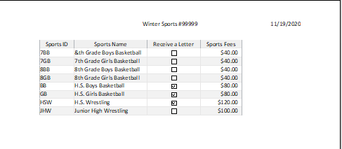

* **Write on paper stating in Table Design, they clicked on Sports ID, then at the bottom put a > on the format line.**

**Job 2**

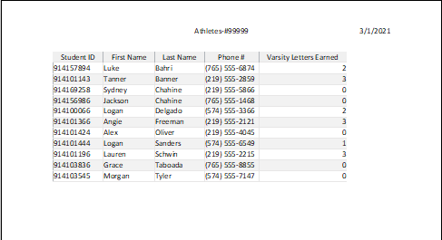

**Job 3**

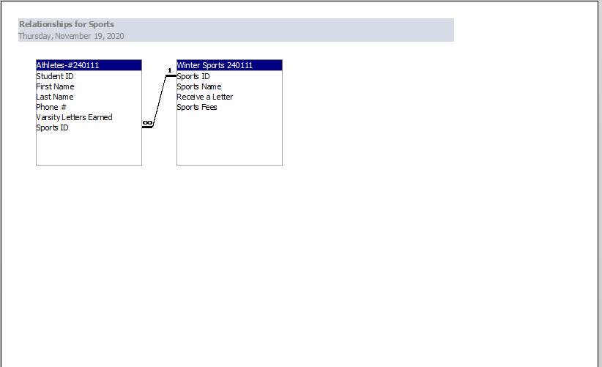

**Job 4**

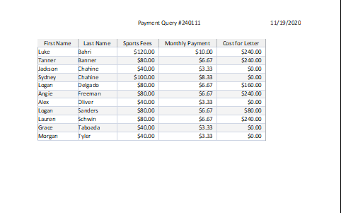

* **First Name must remain in Column 1. Jackson Chahine should come before Sydney Chahine.**

**Job 5**

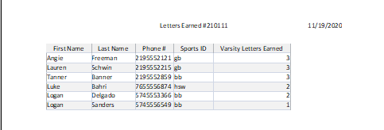

* **Only those that earned a letter should show. They should be in descending order by Varsity Letters Earned.**

**Job 6**

