



ADMINISTRATIVE SUPPORT TEAM

(255)

REGIONAL 2022

**Production:**

Job 1: Memo (100 points)

Job 2: Certificate (150 points)

Job 3: Spreadsheet (125 points)

Job 4: Slideshow Presentation (150 points)

Job 5: Form Development (150 points)

***TOTAL POINTS (675 points)***

**Test Time: 90 minutes**

# General Instructions

***Failure to adhere to any of the following rules will result in disqualification:***

1. Member must hand in this test booklet and all printouts if any.
2. No equipment, supplies, or materials other than those specified for this event are allowed in the testing area. No previous BPA tests and/or sample tests (handwritten, photocopied, or keyed) are allowed in the testing area.
3. Electronic devices will be monitored according to ACT standards.

**EXAM GUIDELINES:**

1. Ensure this test booklet contains Jobs 1 – 5.
2. Key all jobs according to the instructions given.
3. Correct any and all formatting, spelling or grammar errors. Use the formatting guide in the *Style & Reference Manual***.**
4. Your name or initials should *not* appear on any work you submit. Use your Member ID in any occasion you would normally key your reference initials.
5. In the lower **right** hand corner of ALL work submitted (unless otherwise specified), key your Member ID and job number.
6. If you complete the event before the end of the time allotted, notify the proctor. Time may be considered a factor in determining a winner when there is a tie score.
7. Place your scoring sheet on top of your jobs. Jobs should be placed in numerical order.

|  |  |
| --- | --- |
| **PRODUCTION STANDARDS** | |
| 0 Errors | 100 Points |
| 1 Error | 90 Points |
| 2 Errors | 70 Points |
| 3 Errors | 50 Points |
| 4+ Errors | 0 Points |

**TEAM INSTRUCTIONS**

***Congratulations!*** Your Administrative Support Team has been selected to complete a series of projects for the corporate headquarters of Digital Solutions, 700 Morse Road, Suite 201, Columbus, OH 43214. The team reports to Julie Smith in the Human Resources Department. We are initiating a new Internship Program where we will host students from area colleges in various departments in order for the students to gain on-the-job experience. All interns will be paid for their work, and the experience will be for one college semester. Julie has asked your team to complete the following tasks (Jobs) within the next 90 minutes for the new Internship Program at Digital Solutions.

**Scoring Rubric**

|  |  |  |  |
| --- | --- | --- | --- |
| **JOB** | **CRITERIA** | **POINTS POSSIBLE** | **POINTS** |
| **Job 1—**  Memo  *100 points* | Production Standards | 0 errors = 100 points  1 error = 90 points  2 errors = 70 points  3 errors = 50 points  4+ errors = 0 points |  |
|  | Total | /100 |
| **Job 2—**  Certificate  *150 points*  *Logo Development* | Production Standards  Design/Creativity | 0 errors = 100 points  1 error = 90 points  2 errors = 70 points  3 errors = 50 points  4+ errors = 0 points  0-25 points |  |
| Sample Certificate Printed | 0-25 points |  |
|  |  | ***Total*** | /150 |
| **Job 3—**  Spreadsheet  *125 points* | Production Standards | 0 errors = 100 points  1 error = 90 points  2 errors = 70 points  3 errors = 50 points  4+ errors = 0 points |  |
| Sorted by Last Name, First Name, Department | 0-10 points |  |
| Design/Attractiveness | 0-15 points |  |
|  | ***Total*** | /125 |
| **Job 4—**  Presentation  *150 points* | Production Standards | 0 errors = 100 points  1 error = 90 points  2 errors = 70 points  3 errors = 50 points  4+ errors = 0 points |  |
| Design – Creativity | 0-10 points |  |
| Design – Layout | 0-10 points |  |
| Printout – 3 slides per page | 0-10 points |  |
| Logo Inserted | 0-10 points |  |
| Bullets on Slides 2 and 3 | 0-10 points |  |
|  | ***Total*** | /150 |
| **Job 5—**  Form Development *150 points* | Production Standards | 0 errors = 100 points  1 error = 90 points  2 errors = 70 points  3 errors = 50 points  4+ errors = 0 points |  |
| Design – Creativity | 0-20 points |  |
| Design – Layout | 0-20 points |  |
| Logo Inserted | 0-10 points |  |
|  | ***Total*** | /150 |
| ***TOTAL POINTS*** |  | **Points** | **/675** |

**JOB 1 – Memo – 100 Points**

**MEMORANDUM**

To: Department Managers

From: Julie Smith, Human Resources Manager

Date: Current Date

Re: Number of Interns Needed ***Note to Grader: Subject line message will vary.***

As you know, interns play a vital role in the success of Digital Solutions. We are fortunate each year to have valuable summer interns. This year, we are beginning the planning stages now for our Internship Program. Here are just a few of the many tasks an intern can perform:

* + - * Handle all incoming telephone calls
* Greet customers
* Prepare invoices
* Process purchase orders
* Design forms
* Data processing
* Word processing

Please respond by December 20, 2022, as to the number of interns you estimate you will need for the Summer of 2022. We will do our best to fulfill your request. In the meantime, if you have any questions, please let us know.

Team Number

|  |  |  |  |
| --- | --- | --- | --- |
| **Job 1—**  Memo  *100 points* | Production Standards | 0 errors = 100 points  1 error = 90 points  2 errors = 70 points  3 errors = 50 points  4+ errors = 0 points |  |
|  | Total | /100 |

***Note to Grader:***

* If listed items do not contain bullets, count as one error.
* Items highlighted are uncorrected errors on original; count as one errors each.



**JOB 2: Certificate Design – 150 Points**

|  |  |  |  |
| --- | --- | --- | --- |
| Job 2—  Certificate  *100 points*  *Logo Development* | Production Standards  Design  Creativity | 0 errors = 100 points  1 error = 90 points  2 errors = 70 points  3 errors = 50 points  4+ errors = 0 points  0-25 points  0-25 points |  |
|  | Sample Certificate  Prepared and Printed | 0-25 points |  |

**JOB 3: Spreadsheet – 125 Points**

|  |  |  |  |  |  |  |  |  |
| --- | --- | --- | --- | --- | --- | --- | --- | --- |
| ***First Name*** | ***Last Name*** | ***Street Address*** | ***City*** | ***State*** | ***Zip*** | ***Department*** | ***College Attended*** | ***Year Interned*** |
| Amanda | Stiles | 9021 Second Street | Circleville | OH | 45891 | Administrative Support | The Ohio State University | 2020-21 |
| Emily | Brady | 825 Waldron St. | Columbus | OH | 43215 | Administrative Support | The Ohio State University | 2019-20 |
| Robert | Leonard | 2155 Westminster Drive | Columbus | OH | 45343 | Financial Services | Ohio University | 2019-20 |
| Tim | Cole | 9021 Washington Boulevard | Cincinnati | OH | 45890 | Financial Services | University of Cincinnati | 2019-20 |
| Lisa | Brady | 50 South Front Street | Columbus | OH | 45431 | Human Resources | Columbus State Community College | 2020-21 |
| Scott | Balent | 110 Washington Street | Dayton | OH | 45432 | Human Resources | Ohio University | 2018-19 |
| Dorothy | Phelps | 823 Fielding Road | Dayton | OH | 45432 | Information Technology | Shawnee State University | 2019-20 |
| Laura | Franklin | 890 Mallard Avenue | Stow | OH | 45890 | Information Technology | Bluffton University | 2019-20 |
| Diana | Toland | 1733 Fair Oaks Drive | Dayton | OH | 45438 | Marketing | Xavier University | 2020-21 |
| Matthew | Daniel | 7777 Windsor Lane | Defiance | OH | 90987 | Marketing | Defiance College | 2020-21 |

|  |  |  |  |
| --- | --- | --- | --- |
| **Job 3—**  Spreadsheet  *125 points* | Production Standards | 0 errors = 100 points  1 error = 90 points  2 errors = 70 points  3 errors = 50 points  4+ errors = 0 points |  |
| Sorted by Department, Year, Last Name, First Name | 0-10 points |  |
| Design/Attractiveness | 0-15 points |  |
|  | ***Total*** | /125 |

**JOB 4: Presentation – 150 Points**

***Sample Solution – Will vary.***

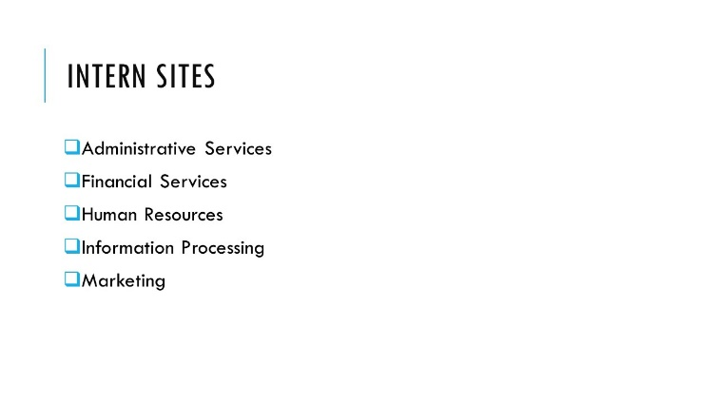



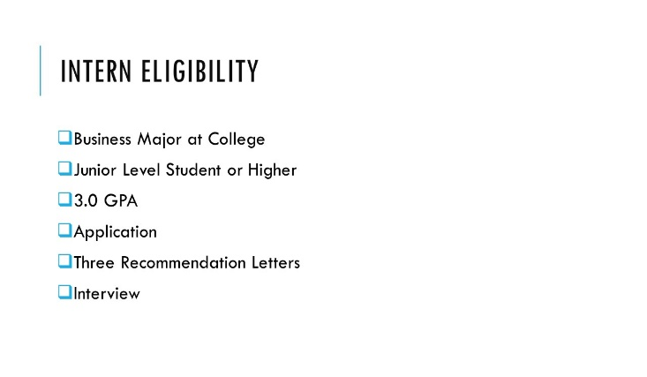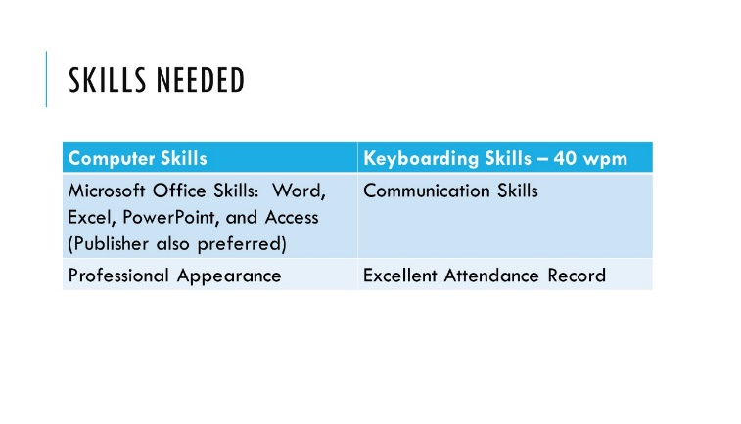

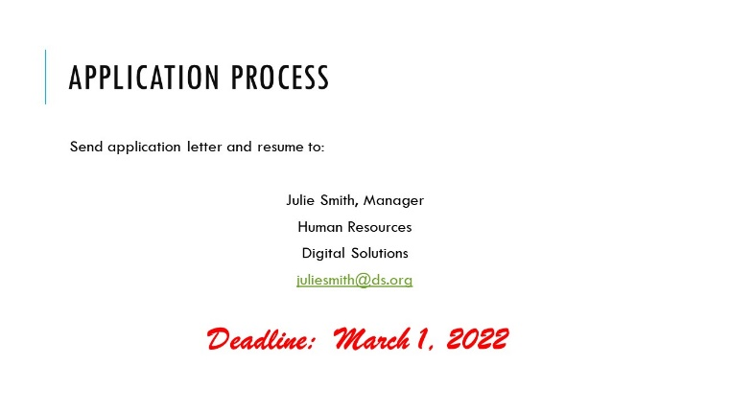

|  |  |  |  |
| --- | --- | --- | --- |
| **Job 4—**  Presentation  *150 points* | Production Standards | 0 errors = 100 points  1 error = 90 points  2 errors = 70 points  3 errors = 50 points  4+ errors = 0 points |  |
| Design – Creativity | 0-10 points |  |
| Design – Layout | 0-10 points |  |
| Printout – 3 slides per page | 0-10 points |  |
| Logo Inserted | 0-10 points |  |
| Bullets on Slides 2 and 3 | 0-10 points |  |
|  | ***Total*** | /150 |

**JOB 5: Presentation – 150 Points**

***Note to Grader: Layout and design will vary. All content must be included.***

**Logo**

**INTERNSHIP APPLICATION**

**DIGITAL SOLUTIONS**

Name

Address City State Zip

Cell Number

College Attending

GPA

Major Minor

Courses Completed Activities/Professional Organizations

Department Desired

Why do you want to become an Intern for Digital Solutions?

What is your career goal?

__________________________ __________________________

Date Signature

|  |  |  |  |
| --- | --- | --- | --- |
| **Job 5—**  Form Development *150 points* | Production Standards | 0 errors = 100 points  1 error = 90 points  2 errors = 70 points  3 errors = 50 points  4+ errors = 0 points |  |
| Design - Creativity | 0-20 points |  |
| Design - Layout | 0-20 points |  |
| Logo Inserted | 0-10 points |  |
|  | ***Total*** | /150 |