



**FUNDAMENTALS OF WEB DESIGN**

(405)

**REGIONAL 2022**

**Production:**

**Multiple Choice (20 @ 5 pts each) __________ (100 points)**

**HTML Application __________ (125 points)**

**CSS Application __________ (75 points)**

**TOTAL POINTS __________ (300 points)**

**Test Time: 90 minutes**

**GENERAL GUIDELINES:**

***Failure to adhere to any of the following rules will result in disqualification:***

1. Member must hand in this test booklet and all printouts if any.
2. No equipment, supplies, or materials other than those specified for this event are allowed in the testing area. No previous BPA tests and/or sample tests (handwritten, photocopied, or keyed) are allowed in the testing area.
3. Electronic devices will be monitored according to ACT standards.

**MULTIPLE CHOICE ANSWER KEY:**

1. **C**
2. **D**
3. **C**
4. **D**
5. **C**
6. **A**
7. **D**
8. **B**
9. **C**
10. **D**
11. **C**
12. **A**
13. **A**
14. **D**
15. **C**
16. **B**
17. **B**
18. **A**
19. **C**
20. **A**

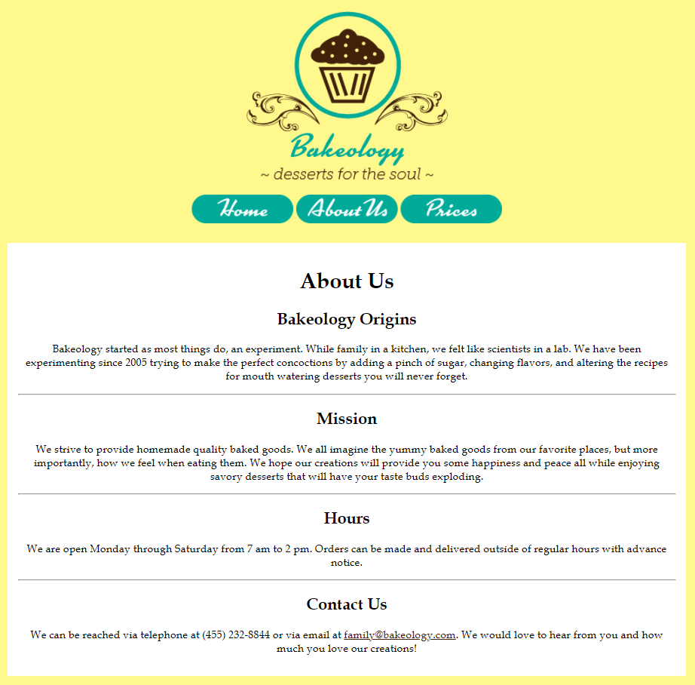

**HTML ANSWER KEY:**

<!doctype html>

<html>

<head>

<link rel="stylesheet" href="stylesheet.css"/>

<title>Home - Contestant ##</title>

<meta charset="utf-8">

</head>

<body class="center">

<img src="bakeology logo.png"/>

<nav>

<img src="home.png" class="navbutton">

<img src="about us.png" class="navbutton">

<img src="prices.png" class="navbutton">

</nav>

<div>

<h1>About Us</h1>

<h2>Bakeology Origins</h2>

<p>Bakeology started as most things do, as an experiment. While cooking as a family in the kitchen, we felt like scientists in a lab. We have been experimenting since 2005 trying to make the perfect concoctions by adding a pinch of sugar, changing flavors, and altering the recipes for mouth-watering desserts you will never forget.</p>

<hr>

<h2>Mission</h2>

<p>We strive to provide homemade quality baked goods. We all imagine the yummy baked goods from our favorite places, but more importantly, how we feel when eating them. We hope our creations will provide you some happiness and peace all while enjoying savory desserts that will have your taste buds exploding.</p>

<hr>

<h2>Hours</h2>

<p>We are open Monday through Saturday from 7 am to 2 pm. Orders can be made and delivered outside of regular hours with advance notice.</p>

<hr>

<h2>Contact Us</h2>

<p>We can be reached via telephone at (455) 232-8844 or via email at <a href="mailto:family@bakeology.com">family@bakeology.com</a>. We would love to hear from you and how much you love our creations!</p>

</div>

</body>

</html>

**CSS ANSWER KEY**

a {

color: #42210B;}

body {

background-color: #FFF98D;

text-align: center;

font-family: 'book antiqua';

width: 1000px;

margin-top: 50px;

color:#42210B;}

div {

background-color: #ffffff;

padding: 15px;}

nav{

margin-bottom:25px;}

.center {

margin-left: auto;

margin-right: auto;}

.navbutton{

width:150px;}

**APPLICATION RUBRIC:**

|  |  |  |
| --- | --- | --- |
| **HTML** | **Point Value** | **Score** |
| Correct DOCTYPE declaration | 5 |  |
| <head> tag properly place and used | 5 |  |
| <title> tag includes Contestant’s BPA membership number | 10 |  |
| <link> tag reference to a CSS stylesheet | 10 |  |
| No style attributes in HTML page | 10 |  |
| Bakeology Logo placed at the top | 5 |  |
| Navigation Button pictures placed at the top and in correct order | 15 |  |
| All heading and text are placed in correct tags | 20 |  |
| Text is free from spelling errors (-5 for each error) | 20 |  |
| All three horizontal rules are in the right place | 15 |  |
| Hyperlink coded correctly with mailto: | 10 |  |
| **HTML TOTAL** | **125** |  |
| **CSS** | **Point Value** | **Score** |
| Style Sheet is external | 10 |  |
| Body background color - #FFF98D text center aligned font-family book antiqua 1000px width 50px top margin font color #42210B | 30 |  |
| Div background color - #FFFFFF 15 px padding | 10 |  |

|  |  |  |
| --- | --- | --- |
| Hyperlinks Color - #42210B | 5 |  |
| Nav Bottom Margin – 25px | 5 |  |
| Class – *Center* left margin – auto right margin – auto applied to body tag | 15 |  |
| **CSS TOTAL** | **75** |  |
|  |  |  |
| **APPLICATION TOTAL** | 200 |  |
| **OBJECTIVE TOTAL** (from page 2) |  |  |
| **EVENT TOTAL** |  |  |